1. Create a user account with the following attribute
  - username: islam
  - Fullname/comment: Islam Askar
  - Password: islam

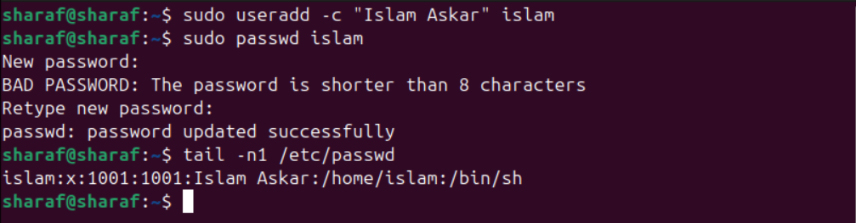
- Create a user account with the following attribute
  - Username: baduser
  - Full name/comment: Bad User
  - Password: baduser

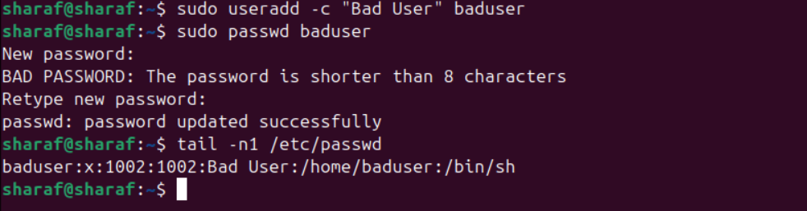
- Create a supplementary (Secondary) group called pgroup with group ID of 30000



- Create a supplementary group called badgroup

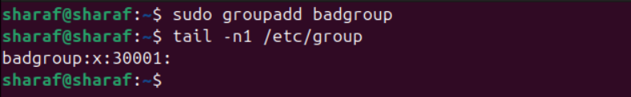
- Add islam user to the pgroup group as a supplementary group

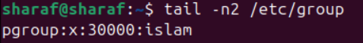
- Modify the password of islam's account to password
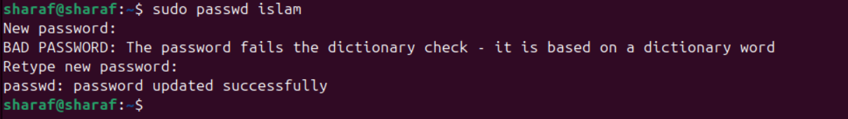
- Modify islam's account so the password expires after 30 days

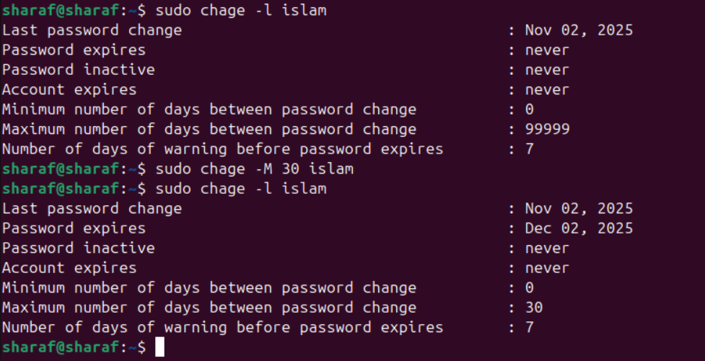

- Lock bad user account so he can't log in
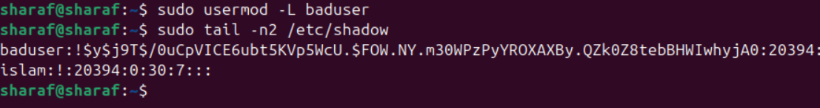
- Delete bad user account
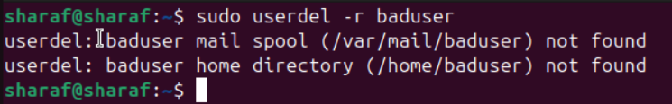
- Delete the supplementary group called badgroup.



